**User Manual**

The Hotel management desktop application includes four main pages whose names are displayed in the left vertical taskbar of the application: Homepage, Room Info, Customer Info, and Reservation. With the help of our team’s application, hotels’ manager staffs now could do their job more easily.

## A. Homepage

First of all, when the users successfully start the application, a homepage will be displayed (picture below). The Homepage suggests a list of available hotel rooms with photos, along with the exact numbers of rooms remaining. An Available status showing in the Room Info page will be counted and grouped by Room Type, then shows the number of available rooms on the Homepage.

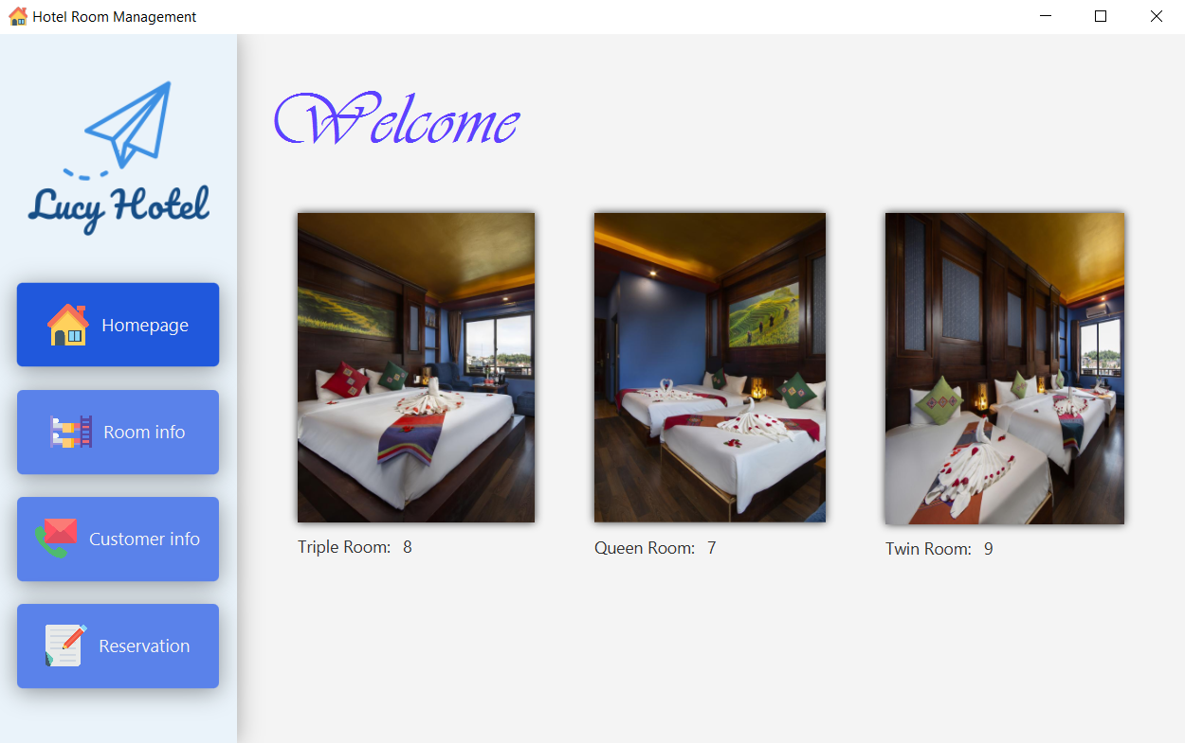

**Figure 5-1: Homepage**

## B. Room Info

**Figure 5-2: Room Information Page**

At first glance, the Room Info page displays all the information of hotel rooms via a table, which are Room Number, Room Type, and Room Status. The page also consists of five important functions (Edit, Delete, Add …) to support the management staffs to check or make a change (if necessary) for every single room.

Looking at the table, each room is indicated with three columns: Room Number, Room Type, and Room Status. By default, the Room Number column is sorted in ascending order from top to bottom. Next, the Room Type column consists of three different values, which are Triple Room, Queen Room, and Twin Room. And finally, the third column (Room status) includes three options, such as Available, Reserved and Staying. Whenever a customer successfully makes a reservation via telephone or directly with hotel staff, the status for the reserved room(s) will automatically change from Available to Reserved. On the first valid day of the reservation, the Status of the room will be replaced with Staying.

As mentioned earlier, there are five functions, namely, Sort by Room Type, Sort by Room Status, Edit, Delete and Add Room.

With the help of the first two functions, room information can be sorted by either Room Type or Room Status. For the Room Type sort function, users can choose one of four choices, which are All, Twin Room, Triple Room, and Queen Room. For the Room Status sort, the options are All, Available, Reserved, and Staying. The images below provide examples when users trying to use the sorting functions.

**Figure 5-3: Sorted by Room Type**

**Figure 5-4: Sorted by Room Status**

**Figure 5-5: Sorted by Room Type and Room Status**

Besides, users can modify room information, with Edit and Delete functions, by doing the following steps.

* Step 1: Choose a room to modify
* Step 2: Click Edit or Delete button
* Step 3:
* Edit Room: Because the room numbers are unique, users cannot overwrite them. However, users can modify the two other room parameters which are Room Type and Room Status.

**Figure 5-6: Edit Room Dialog**

* Delete Room: Whenever the users click on the Delete button for a specific room, a confirmation window will be pop-up immediately (below picture). Users can press OK to verify their decision or Cancel to return to the previous state.

**Figure 5-7: Delete Room Dialog**

After that, the room information will be updated in the table.

**Figure 5-8: After modification (edit and delete)**

In another case, if users do not choose a room in the table before modification, the system will show the error dialog.

**Figure 5-9: Error notification**

To create a new room, users can use Add function. Implementation steps are as follows:

* Step 1: Click Add button
* Step 2: Fill in all the information
* Step 3: Click OK, then the room is successfully created. Otherwise, no room will be added to the database.

**Figure 5-10: Add Room**

In step 2, if users do not provide enough needed information, the system will display an error dialog like below:

**Figure 5-11: Invalid either Room type or Room Status**

**Figure 5-12: Invalid Room Number**

## C. Customer Info

The third page, Customer Info, supports the hotel staff to manage the personal information and booking information of customers more easily.

On the left-hand side of the page, there are a Search box and a table that consists of Customer ID, First Name, and Last Name. To the right side, all customers’ personal information is displayed via a form. Moreover, to view booking information, users can just click the ‘Show booking info’ button.

**Figure 5-13: Customer Information Page**

Regarding the functions including in this page, the Search box helps users to find the personal information of customers that exists in the table.

**Figure 5-14: Search for Customer Information**

If users do not choose any customer information in the table, the personal information is empty. Otherwise, it is filled with all detailed information.

**Figure 5-15: Show Personal Information**

As mentioned previously, ‘Show booking info’ function displays all booking information of the chosen customer.

**Figure 5-16: Show Booking Information**

In this dialog, it contains a table with all booking information, such as, Booking ID, Check-in Date, Check-out Date, Booking Method and Room Number. The Check-in after and Check-out before boxes are used to sort out the Booking information of the chosen customer.

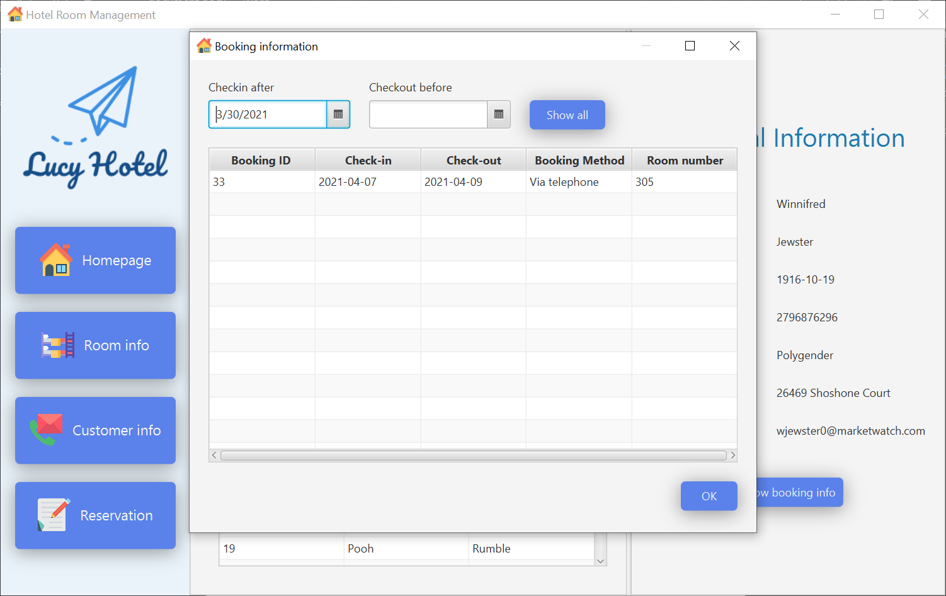

**Figure 5-17: Sorted by either Check-in date or Check-out date**

There is also a Show all button with is aimed to show all booking information again after sorting.

## D. Reservation

The Reservation page helps hotel staff collecting the booking information from customer.

**Figure 5-18: Reservation form**

Whenever users navigate to the Reservation page, a blank form will appear. This form can be filled in by two different ways:

* Option 1: For new customers, users input manually all Personal Information and Booking Information and then hit the ‘Submit’ button.

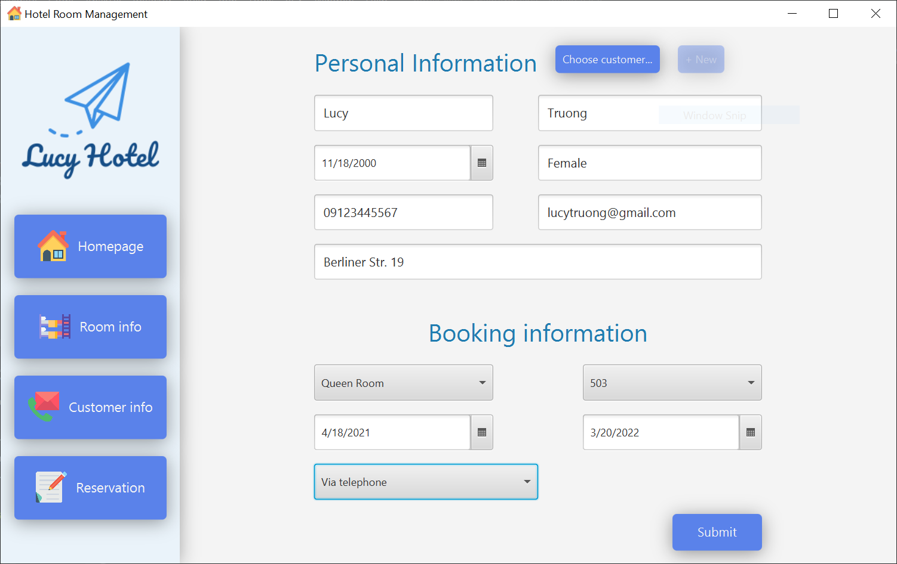

**Figure 5-19: The form is manually filled**

* Option 2: For customers who have already stayed in the hotel:
* Step 1: Users click ‘Choose customer’ button. Then, a dialog, which imitates Customer info page, will automatically pop-up.

**Figure 5-20: Make a reservation for the customer who had already stayed in the hotel**

* Step 2: Choose the correct customer information in the suggestion list.

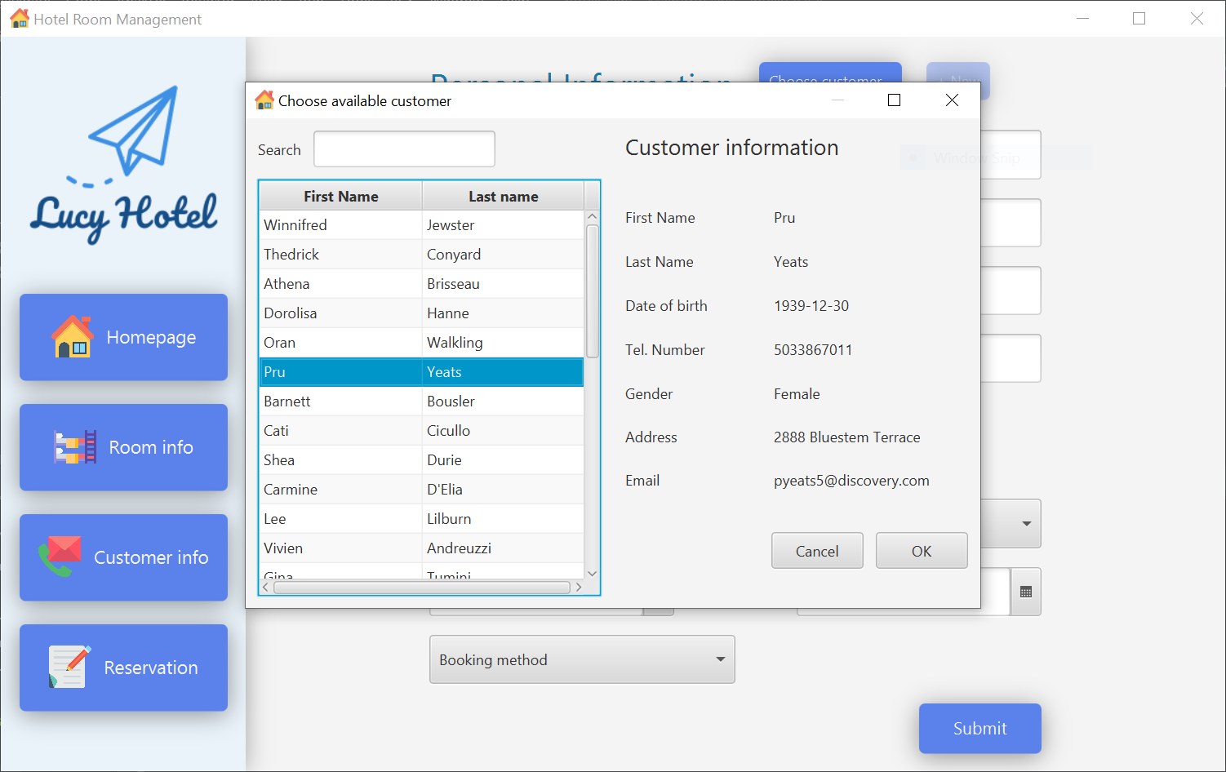

**Figure 5-21: Choose available customer**

* Step 3: Click OK and finally, all the needed information is automatically filled in the form.

**Figure 5-22: All personal information is automatically filled**

* Step 4: The users insert all booking information and submit the reservation. This step will change the status of the reserved room to Reserved and add this booking to the Booking Information page.

In option 2, there is one more function which is the last function of our team’s application, the + New function. This function is aimed to support users to refresh the form to a blank form, whenever users receive wrong information, same as Figure 3-18.

In addition, an error dialog will be pop-up like the below picture, whenever users do not provide enough information of the form.

**Figure 5-23: Invalid Information**

# Appendix

## Use Case Diagram

**Figure 6-1: Use Case Diagram - Room Information Page**

**Figure 6-2: Use Case Diagram - Customer Information Page**

**Figure 6-3: Use Case Diagram - Reservation Page**

## Sequence diagram

**Figure 7-1: Sequence Diagram - Homepage**

**Figure 7-2: Sequence Diagram - Room Information Page**

**Figure 7-3: Sequence Diagram - Customer Information Page**

**Figure 7-4: Sequence Diagram - Reservation Page**

## Entity Relational Diagram

**Figure 8-1: Database - ER Diagram**